**Force System Instructions**

***C:\Users\Public\Documents\LabVIEW Fatigue Vis\ Simple Force Multi Submax Radio***

**1)** Open NI MAX

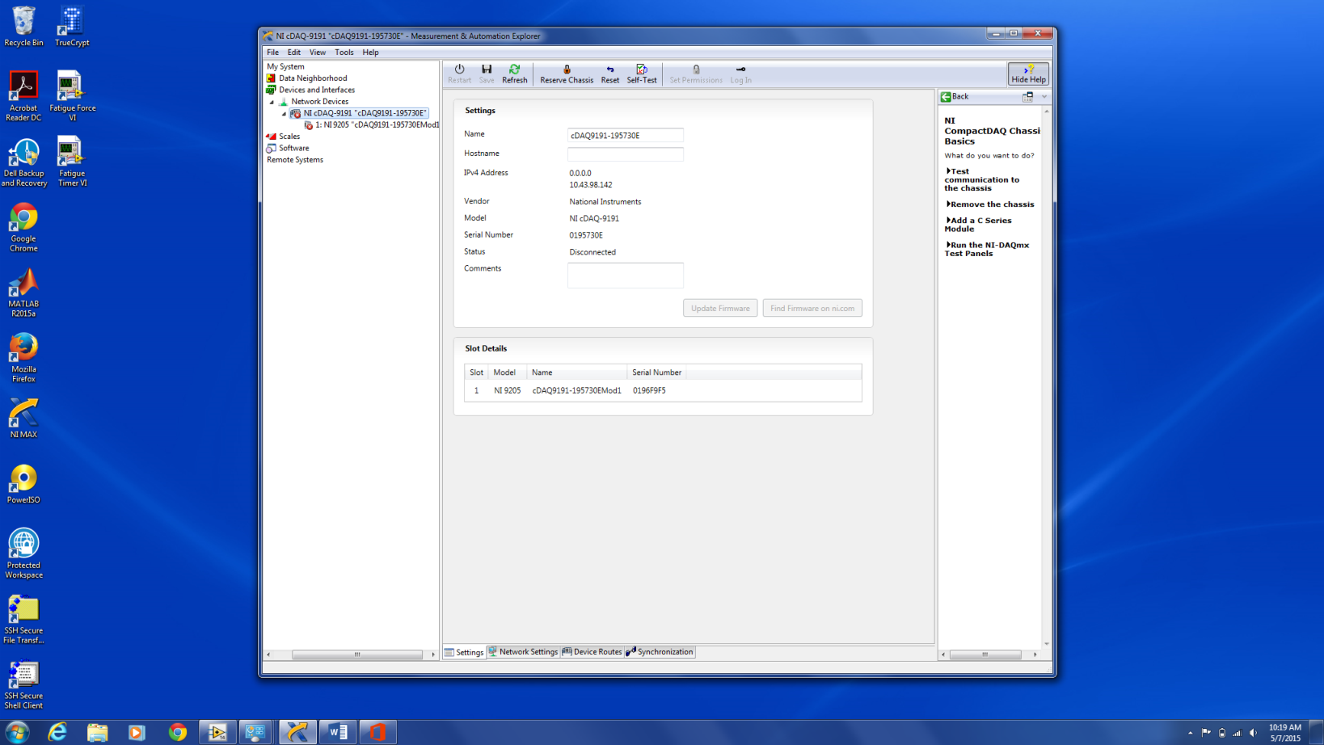

**2)** Click on the “Network Devices” tab on the left.

**3)** You should see “NI cDAQ….” ending with a ‘B’ or and ‘E’ depending on which force box you are using.

**4)** If you see the cDAQ and it is connected, as shown in the bottom figure, continue to step 5. If it is not connected, as shown in the top figure, continue to step 4A.

**4A)** Check for the following:

* The force box is on and connected to the internet
* The laptop is connected to the same network as the force box (usually vummiv)
* The chassis is reserved for the laptop. If it is already reserved for the laptop, the button will say “Unreserve Chassis” as shown in the bottom figure - this is what you want. If it is reserved for another laptop, there will be a button that says, “Reserve Chassis” as shown in the top figure. Click this button and authorize to disconnect the chassis from the other laptop.

**5)** Click the “Self-Test” button at the top of the window to verify the force system is communicating with the laptop. If the status says “Connected – Running”, you should be good to go. (If the volume on the laptop is not muted, you will hear the device connecting to the computer.)

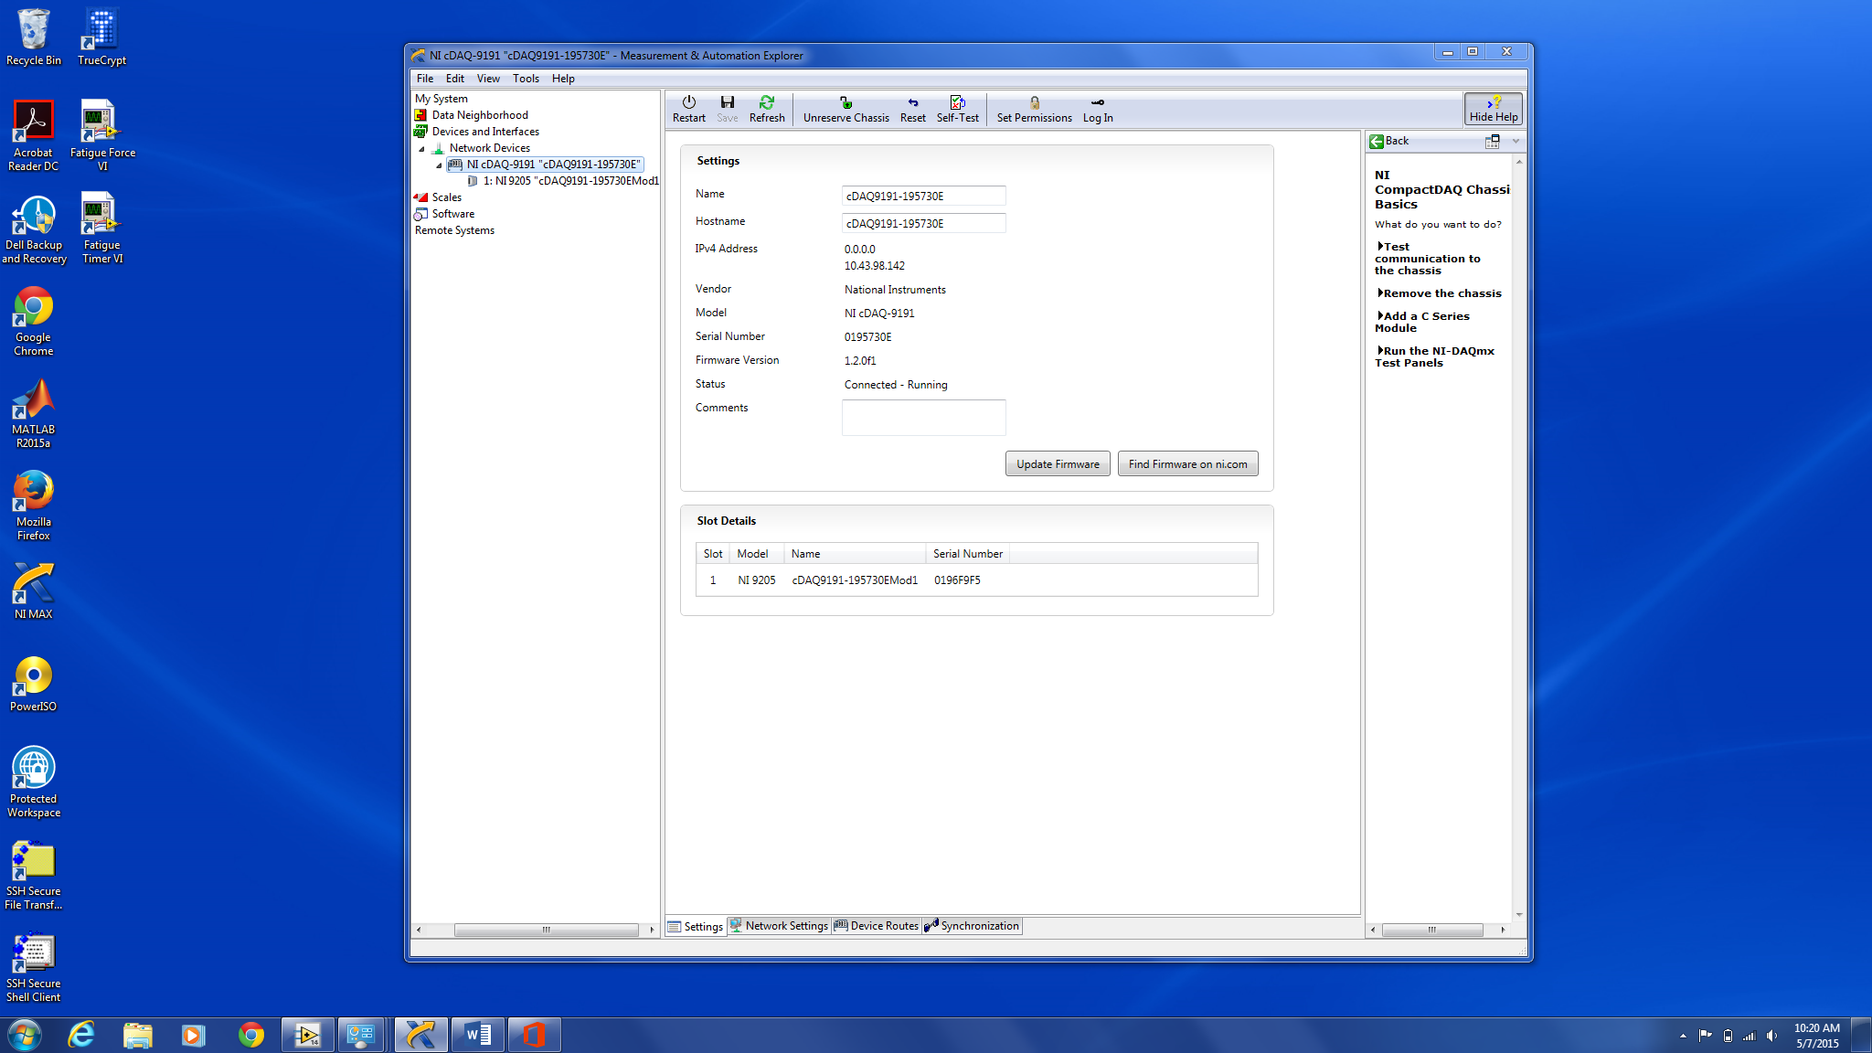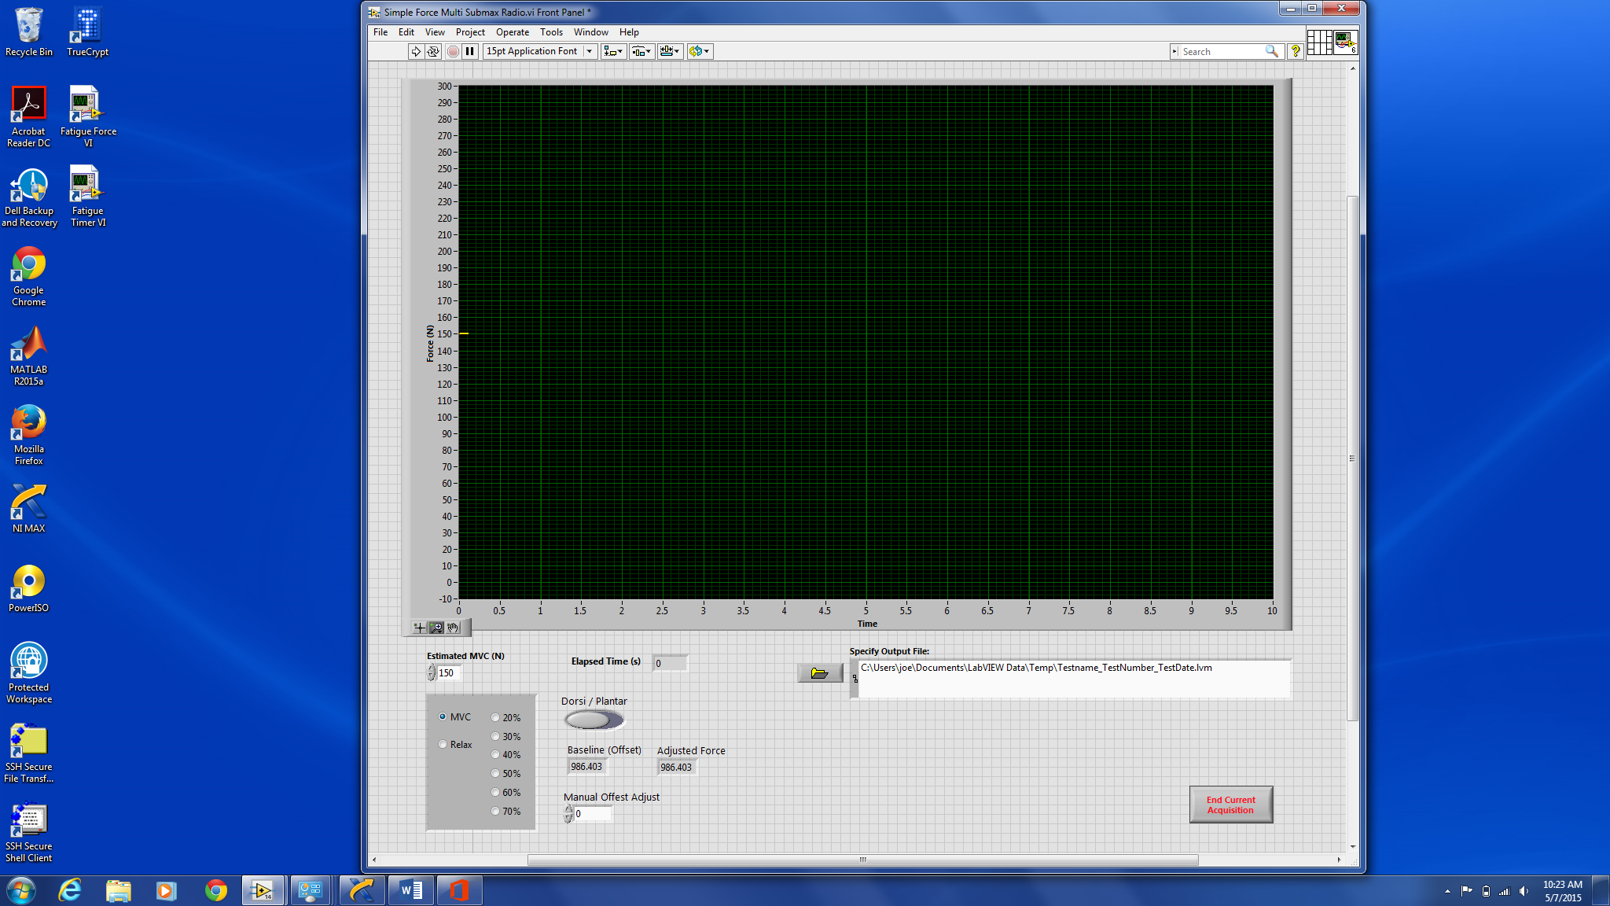

**Enter in MVC here.**

**Radio buttons can be used to quickly switch between MCV, relax, and submax target forces. These are auto calculated based on the input for “Estimated MVC (N)”.**

**While VI is running, enter in value from “Baseline (Offset)” box into “Manual Offset Adjust” box to bring baseline to 0. “Adjusted Force” should then read close to 0.**

**Use to switch between dorsi and plantar**

**Enter output file.**

**\*VI will not run without a valid output file.**

**6)** Open “Fatigue Force VI”. If there is no icon, this file can be found in the following directory: *C:\Users\Public\Documents\LabVIEW Fatigue VIs* and the file name is *“Simple Force Multi Submax Radio”.*



**Click arrow to run VI.**

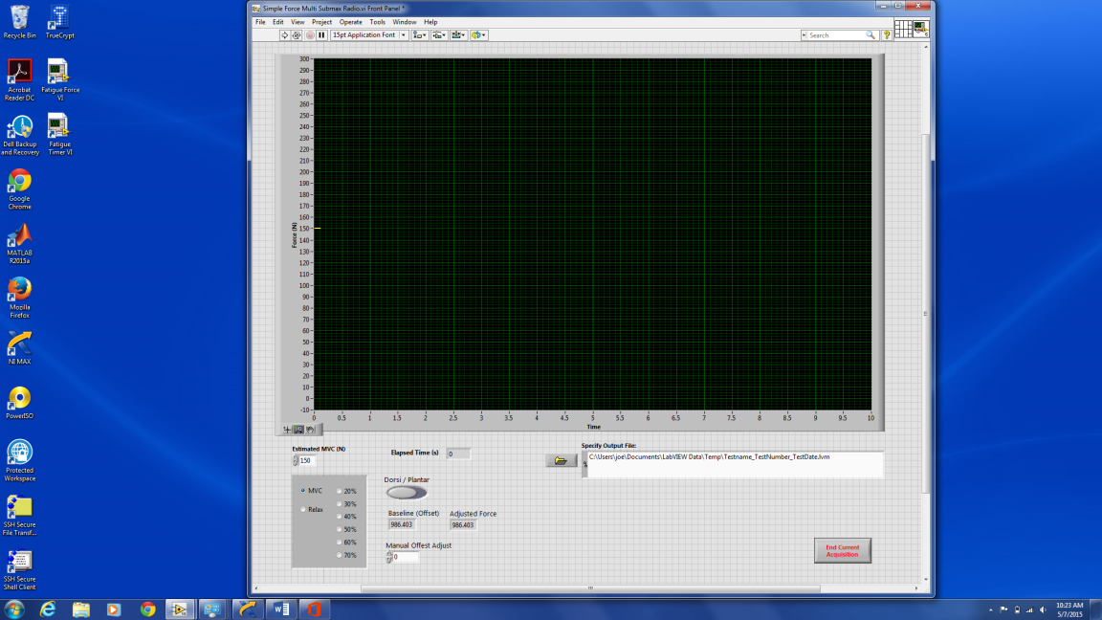

**7)** Enter in an output file.

**8)** Click the arrow to run the VI.

**9)** Use the control panel to adjust the settings as needed.

**If you get the error displayed in the figure…**

**1)** Press “Stop”

**2)** Double click the “DAQ Assistant” which will open up a new window.

**Force System Troubleshooting**

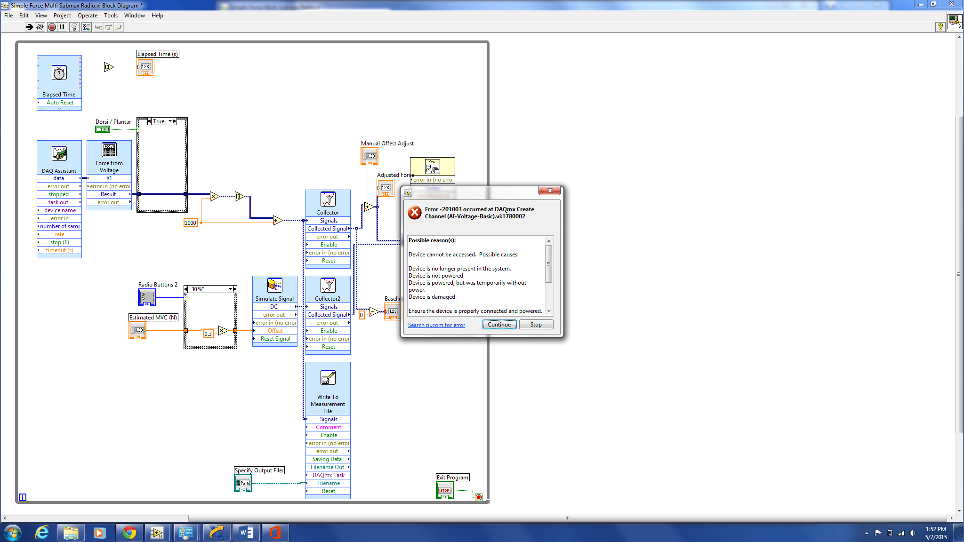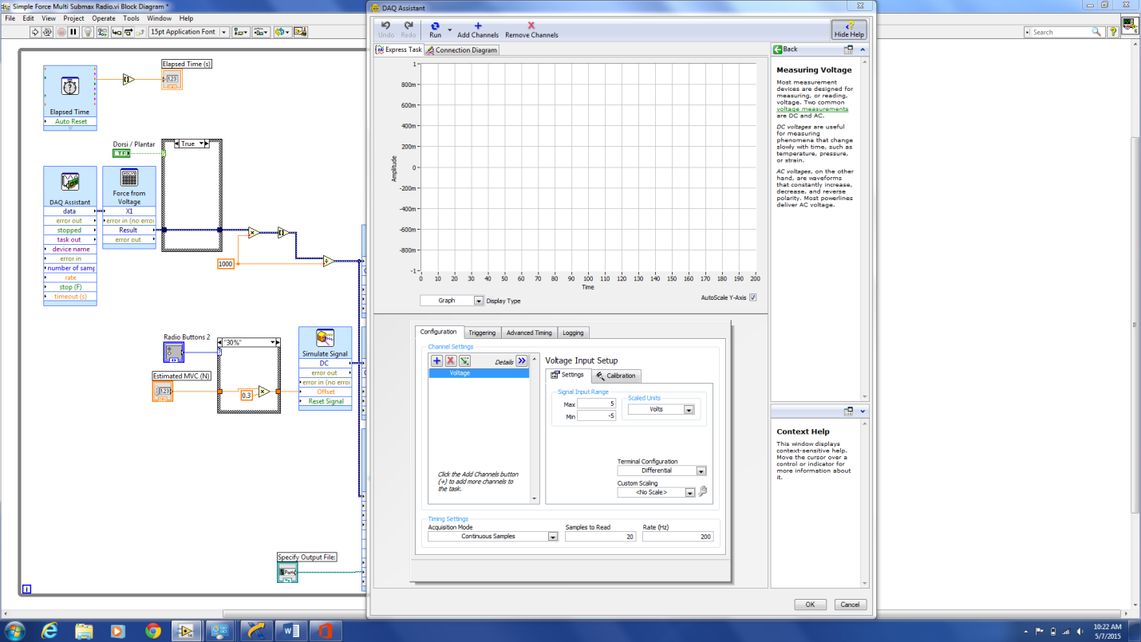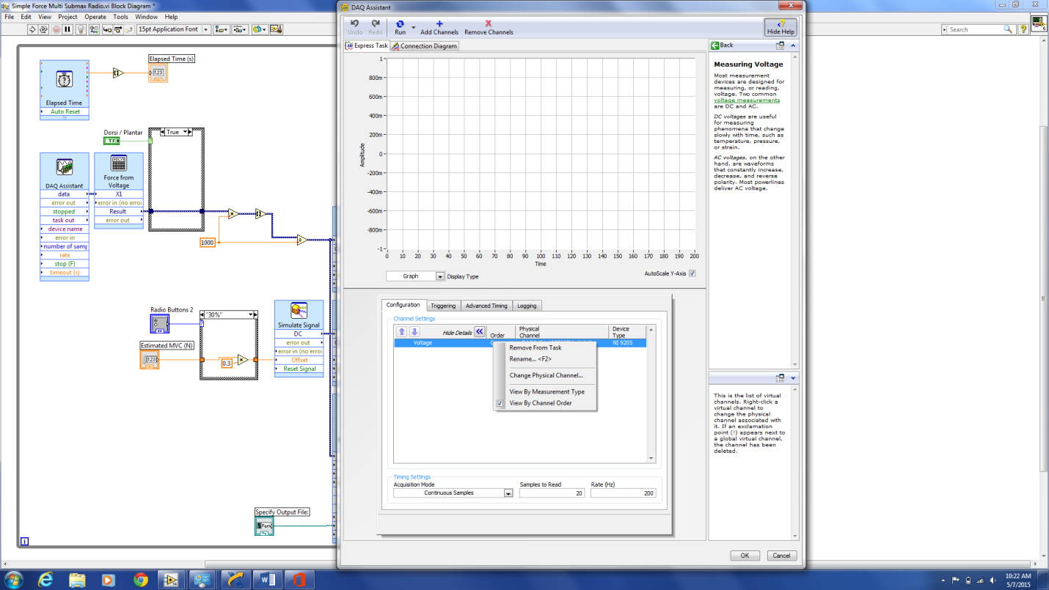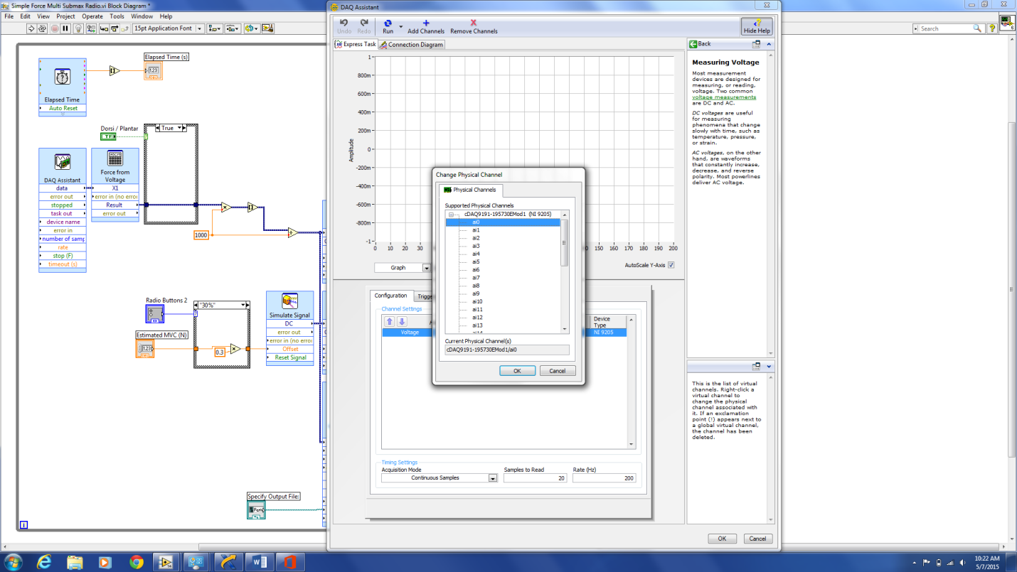

**3)** Right click where it says “Voltage” and select “Change Physical Channel”.

**4)** In the new window, select “a0”. (Tip: if a0 is already selected, highlight a different channel before re-selecting a0.) If this window is not populated, go back to the NI MAX instructions and make sure the device is connected to the laptop.

**5)** Press “OK” in the Physical Channel window and “OK” again in the DAQ Assistant window. A notification should pop up that the force VI is building. Once this is finished you should be good to go.